**Create a flow to manage project approvals**

**Step 1: Configure the flow template**

1. In the **Project Requests** list, click or tap **Flow**, then **Create a flow**.

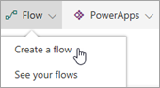

1. In the right pane, click or tap **Start approval when a new item is added**.

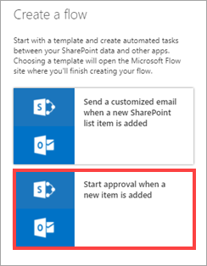

1. If you're not already signed in, sign into SharePoint and Outlook, then click or tap **Continue**.

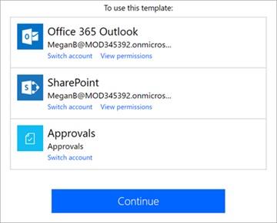

You now see the template for this flow, ready for you to complete. The boxes in the flow represent steps. They take input from previous steps, as well as input that you provide. Each step can then provide output to subsequent steps.

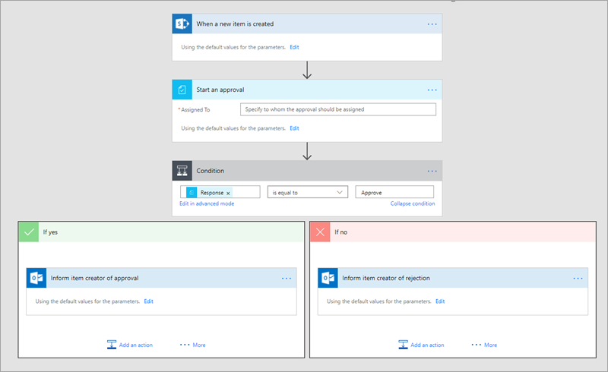

1. In the **Assigned To** box, enter a name that is valid in your tenant.

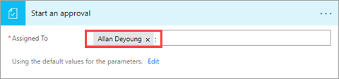

The next box in the flow responds to the project approver's decision and routes the flow to one of two *branches*: **If yes** or **If no**.

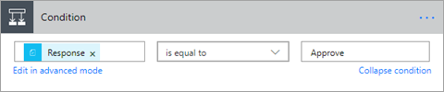

**Step 2: Create actions for Approve = yes**

By default, this branch sends an approval email to the requestor. We'll also update the **Project Requests** list, and add an item to the **Project Details** list because the project has been approved.

1. In the **If yes** branch, click or tap **Inform item creator of approval**, then **Edit** to see the default options for the email sent to the requestor.

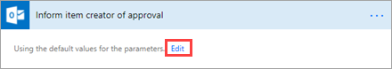

1. By default, an email is sent to the person who created the list item, with the subject line and message body that you see. You can update these if you like.

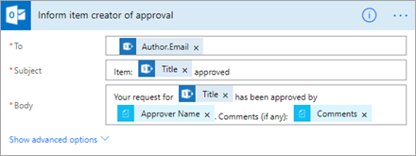

1. Click or tap **Add an Action**.

Add an action.

1. Under **Choose an action**, search for "SharePoint", then click or tap **SharePoint – Update item**.

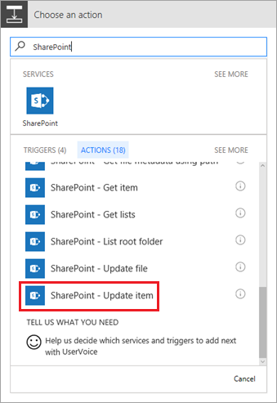

1. Enter the SharePoint site URL and list name.

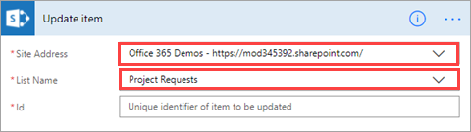

1. Select the **Id** box, then click or tap **ID** in the *dynamic content* dialog box.

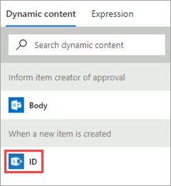

Dynamic content is available throughout the flow, based on previous steps. In this case, the SharePoint list information is available, and we can use it in the actions that we create.

1. Select the **Title** box, search for "Title" in the dynamic content dialog box, then click or tap **Title**.

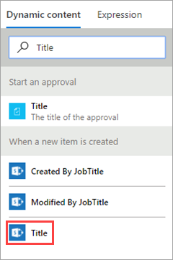

1. In the **Approved** box, enter "Yes". This part of the flow should now look like the following image.

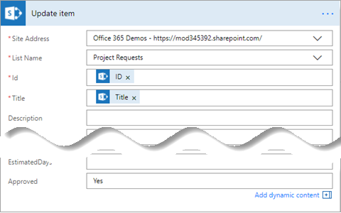

1. Click or tap **Add an Action** again. This time we'll add an item to the **Project Details** list for the project that was approved.

Add an action.

1. Under **Choose an action**, search for "SharePoint", then select **SharePoint – Create item**.

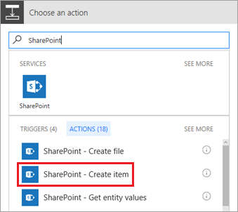

1. Enter the SharePoint site URL and list name.

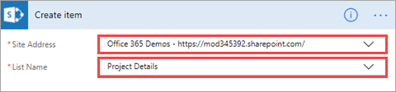

1. Select the **Title** box, search for "Title" in the dynamic content dialog box, then click or tap **Title**.



1. Select the **RequestId** box, then click or tap **ID** in the dynamic content dialog box.



1. In the **PMAssigned** box, enter "Unassigned". This part of the flow should now look like the following image.

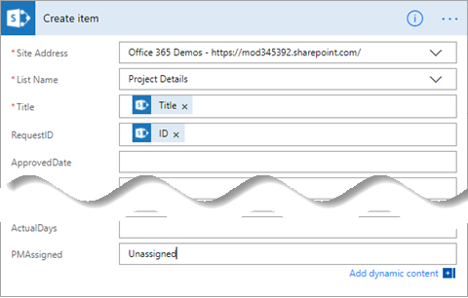

**Step 3: Review action for Approve = no**

By default, this branch sends a rejection email to the requestor. We'll also update the **Project Requests** list. The project isn't moving forward, so we don't add an item to the **Project Details** list.

1. In the **If no** branch, click or tap **Inform item creator of rejection**, then **Edit** to see the default options for the email sent to the requestor.

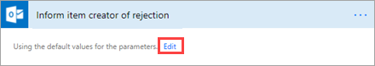

1. By default, an email is sent to the person who created the list item, with the subject line and message body that you see. You can update these if you like.

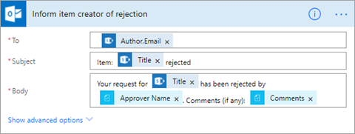

1. Click or tap **Add an Action**.

Add an action.

1. Under **Choose an action**, search for "SharePoint", then click or tap **SharePoint – Update item**.



1. Enter the SharePoint site URL and list name.



1. Select the **Id** box, then click or tap **ID** in the dynamic content dialog box.



1. Select the **Title** box, search for "Title" in the dynamic content dialog box, then click or tap **Title**.



1. In the **Approved** box, enter "No". This part of the flow should now look like the following image.

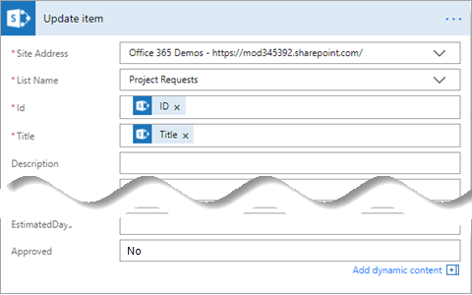

1. At the top right of the screen, click or tap **Create flow**.

The flow is now complete, and it should look like the following image if you collapse the boxes.

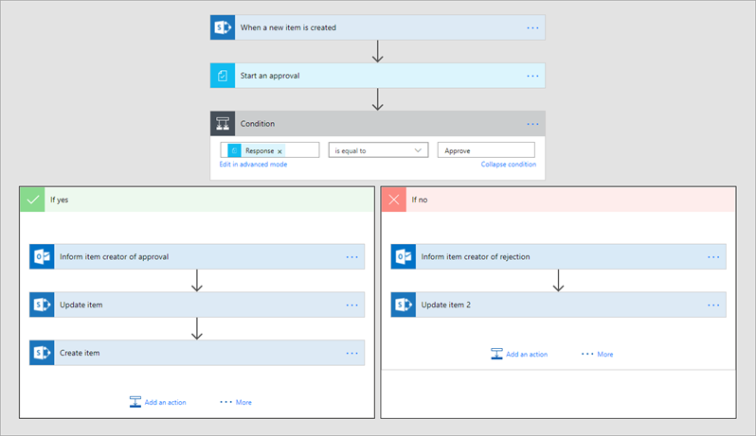

1. At the top right of the screen, click or tap **Done**.

Done button.

**Step 4: Run the approval flow**

1. In the **Project Requests** list, click **Quick Edit** and add an item like the following:
   * **Title** = "New monitor for Megan"
   * **Description** = "Megan needs a 24" monitor"
   * **ProjectType** = "New hardware"
   * **RequestDate** = "02/03/2017"
   * **Requestor** = "Megan Bowen"
   * **EstimatedDays** = "1"
   * **Approved** = "Pending"



1. Click **Done** at the top of the page when you're finished.

Done check mark.

1. Check the inbox of the approver's email account. You should have an email like the following.

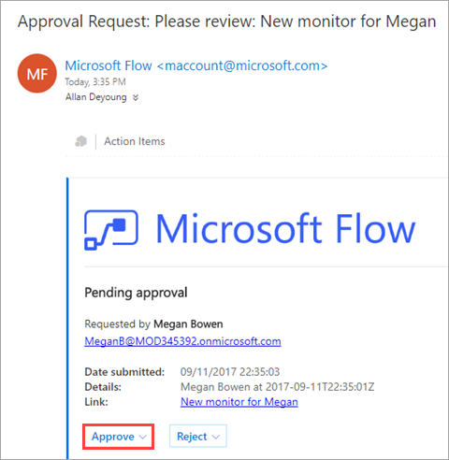

1. After you click **Approve** or **Reject**, the flow runs another process, and you get feedback like the following, directly in the email.

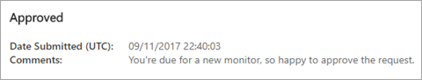

1. The flow sends an email to Megan with Allan's response, as in the following image. This email comes *from* Megan because she owns the flow.

